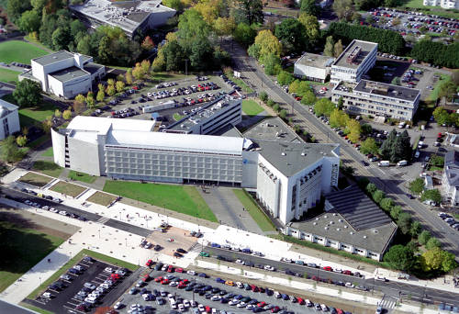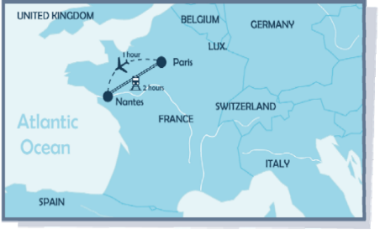
Call for Papers – EDSI 2023 Audencia Business School, Nantes France
4-7 June, 2023

13th European Decision Sciences Conference
https://edsi.decisionsciences.org/conference
Building resilience for sustainable transition

The necessity for the development of new business models to combat the looming energy crisis, to prepare for the digital disruption, to improve supply chain transparency and security, to ensure diversity and inclusion, mental health and physical wellbeing in workplaces, generate a challenging new environment for managers across all the functional areas of an organisation. With increased risks along the supply chain, building resilience has become a pivotal topic for sustained organizational survival and growth. The conference will provide a forum for academics as well as practitioners to present research papers and discuss opportunities to improve effectiveness and innovation in organisations. The underlying intent will be to generate insights into the radical changes and develop innovative decision-making models for responsible organizational performance.

Conference Chair
Professor Mihalis Giannakis
Local Organizing Committee
Professor Rhona Johnsen
Professor Thomas Johnsen
Dr Konstantina Spanaki
Dr Leonardo Marques
Dr Jean-Mark Charlot
Ms Alice Anohan
Outline Program
Sunday 4th June | - Registration  - Doctoral workshop  - Welcome Reception
Monday 5th June | - Registration  - Academic Keynote  - Parallel sessions  - Business Keynote  - Parallel sessions  - Gala dinner
Tuesday 6th June | - Academic Keynote  - Parallel sessions  - Business Keynote  - Parallel sessions  - Dinner
Wednesday 4th June (Subject to numbers) | - Industrial Visit  - Cultural Visit
Important Dates / Deadlines
Abstract submission: February 10th, 2023
Notification of acceptance: February 28th, 2023
Full paper submission (optional): April 7st, 2023
Workshop Proposal Deadline: February 10th, 2023
Conference Fees
Early Bird registration until April 7th, 2023
DSI members, €400
Non-DSI members, €500
PhD student, €200
Spouse/Partner, €200
Standard registration after April 7th, 2023
DSI members, €450
Non-DSI members, €550
PhD student, €250
Spouse/Partner, €250
Early/Standard fee includes all lunches, dinners and coffee breaks during the conference as well as the Gala dinner taking place at the end of Day 2, June 5th 2023.
Call for Papers
English is the official language of the conference. All submissions should be made electronically. We welcome abstract, paper and poster submissions. Prospective authors are invited to submit original research abstracts / papers / posters (NOT submitted or published or under consideration anywhere in other conferences/journals).
Presentations at the conference will be based on submission and acceptance of an abstract (up to 250 words). Following abstract acceptance, delegates will have the option to submit a full paper, addressing the review comments.
Alternatively, you can submit a poster to our poster session. If you choose to submit a poster, an abstract should be submitted using our submission system.
All accepted abstracts and papers will be available in the Conference Proceedings.
Topics
EDSI 2023 invites contributions from across all the disciplines relevant to the decision sciences, including analytics, modelling, and qualitative studies. Topics include but are not limited to:
- Accounting, financial, and marketing decision making in organizations.
- AI driven decision science
- Business Analytics
- Behavioural Operations
- Blockchain Technology
- Cyber Security and System Resilience
- Decision Making in Public Organizations
- Decision Support Systems
- Decision Sciences in Practice
- Decision Theory
- Design Thinking and Innovation
- Digital Business Transformation
- Diversity, Equity and Inclusion
- Energy Transition
- Healthcare Operations
- Humanitarian Operations & Disaster Management
- Industry 4.0
- Information Systems / Information Technology
- Innovative Education
- Interfaces between Functional Areas (Operations, Strategy, Finance, IT, Marketing, HRM)
- Logistics and Transportation
- Operations Planning and Control
- Operations Strategy
- Performance Measurement and Management
- Project Management
- Purchasing, Procurement and Sourcing
- Responsible Data Science
- Quality Management and Lean Operations
- Service Systems and Operations
- Strategic Management
- Supply Chain Management
- Supply Chain Risk and Resilience
- Sustainability and CSR
- Technology Management

Paper submission instructions can be found at
https://edsi.decisionsciences.org/call-for-papers/
Papers should be submitted directly at https://app.oxfordabstracts.com/

Scientific Committee

Melek Akın Ateş, Sabanci University, Turkey
Spyros Angelopoulos, Durham University, UK
Mohamed Zied Babai, Kedge Business School, France
Frédéric Babonneau Kedge Business School, France Sabine Baumann, Jade University, Germany
Constantin Blome, University of Sussex, UK
Steven Carnovale, RIT, USA
James Byrne Dublin City University, Ireland
PJ Byrne, Dublin City University, Ireland
Federico Caniato, Politecnico di Milano, Italy
Ioanna Constantiou, CBS, Denmark
Simon Croom, University of San Diego, USA
Carmela Di Mauro, University of Catania, Italy
Rameshwar Dubey, Montpellier Business School, France
Yogesh Dwivedi, Swansea University, UK
Lisa Ellram, Miami University, USA
Marco Formentini, University of Trento, Italy
Jose Arturo Garza-Reyes, University of Derby, UK
Dmitry Ivanov, HWR Berlin, Germany
Louise Knight University of Twente, Netherlands
Xenophon Koufteros, Texas A&M University, USA
Markku Kuula, Aalto University, Finland
Annachiara Longoni, ESADE Business School, Spain
Davide Luzzini, EADA Business School, Spain
Joe Miemczyk, ESCP Business School, UK
Patrick Mikalef, NTNU, Norway
Bartholomew MacCarthy, University of Nottingham, UK
Guido Nassimbeni, University of Udine, Italy
Jan Olhager, Lund University, Sweden
Guido Orzes. Free University of Bozen-Bolzano. Italy
Mark Pagell, University College Dublin, Ireland
Ilias Pappas, University of Adger, Norway
Jakob Rehme, Linköping University, Sweden
Frantz Rowe, University of Nantes, France
Funda Sahin, University of Houston, USA
Marco Sartor, University of Udine, Italy
Tobias Schoenherr, Michigan State University, USA
Sri Sridharan, Clemson University, USA
Anuragini Shirish, Université Paris-Saclay, France
Shirish Srivastava, HEC Paris, France
Morgan Swink, Texas Christian University, USA
Sri Talluri, Michigan State University, USA
Ou Tang, Professor, Linköping University, Sweden
Wendy Tate, University of Tennessee, USA
Xenia Vasilakopoulou, University of Adger, Norway
Gyula Vastag, Széchenyi University, Hungary
Samuel Fosso Wamba, TBS, France
Andreas Wieland, CBS, Denmark
Stephan M. Wagner, ETH Zurich, Switzerland
Efpraxia Zamani, University of Sheffield, UK
Linda L. Zhang, IESEG School of Management, France

Workshops/Special Tracks
The Conference offers the opportunity to provide a limited number of professional development workshops and/or special tracks. These should be relevant to the core theme of the conference and intended to help delegates improve their skills. Please send your suggestions to edsi2023@audencia.com
Best Paper Awards
Two best paper prizes will be awarded – one for the best theory-oriented paper and one for the best applications-oriented paper presented at the conference. Prizes will also be awarded for the best PhD student presentation and best poster. Note that papers can only be submitted to one prize category. Evaluation: The EDSI Board will convene the best papers nomination panel.

